**Project Initialization and Planning Phase**

| Date | 03 February 2025 |
| --- | --- |
| Team ID | xxxxxx |
| Project Name | Implementing AgriPrediction using Machine Learning |
| Maximum Marks | 3 Marks |

**Define Problem Statements (**Implementing AgriPrediction using Machine Learning**):**

Farmers and agricultural stakeholders face significant challenges in accurately predicting crop yields, soil conditions, weather patterns, and pest infestations. Traditional farming practices often depend on experience and intuition, making it difficult to adapt to changing environmental conditions and optimize agricultural productivity. Factors such as climate change, unpredictable weather, and inefficient resource utilization further increase risks, leading to reduced yields, financial losses, and food insecurity.

Existing agricultural prediction tools often lack precision, real-time insights, and personalized recommendations, leaving farmers with unreliable data for critical decision-making. Without an intelligent and data-driven approach, farmers struggle with inefficient planning, improper resource allocation, and susceptibility to unforeseen agricultural challenges.

By implementing AgriPrediction using machine learning, we can equip farmers with a smart, predictive system that analyzes vast agricultural datasets, provides accurate forecasts, and offers actionable insights. This solution enhances productivity, minimizes risks, and promotes sustainable farming practices through advanced data-driven decision-making.

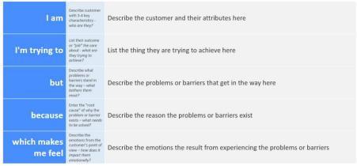

Reference: https://miro.com/templates/customer-problem-statement/

**Example:**

|  |  |  |  |  |  |
| --- | --- | --- | --- | --- | --- |
| **Problem**  **Statement (PS)** | **I am**  **(Customer)** | **I’m trying to** | **But** | **Because** | **Which makes me feel** |
| PS-1 | A farmer or agricultural stakeholder | Predict crop yields, soil conditions, and weather patterns | Traditional methods rely on intuition rather than data-driven insights | Climate change, pest outbreaks, and resource inefficiencies impact productivity | Uncertain about my yield, leading to financial instability and stress |
| PS-2 | A farmer looking for better decision-making tools | Use accurate and real-time agricultural predictions | Existing prediction tools lack precision and adaptability | I don’t have access to a reliable machine learning-based system | Frustrated, as I cannot optimize my resources and maximize profitability |